**To:** Jie Yang

**From:** Team 5 - Evan Genuise, Mason Gerace, William McGerty, Aidan Nash, Joshua Pollock

**Date:** October 3rd, 2018

**RE:** Project 2: Deliverable 1: Gantt Chart/WBS

Having an organized work schedule is critical when working on a project. To organize our work flow and ensure that we meet assignment deadlines for Project 2, our team has created a Gantt Chart and a WBS (Work Breakdown Structure). The tasks in the Gantt Chart contain deadlines that we must meet to complete our project successfully. Our WBS assigns teammates to specific tasks and indicates who has completed each task. If a teammate who completed a task was different than the teammate who was originally assigned the task, a justification will be given.

**Figure 1.**

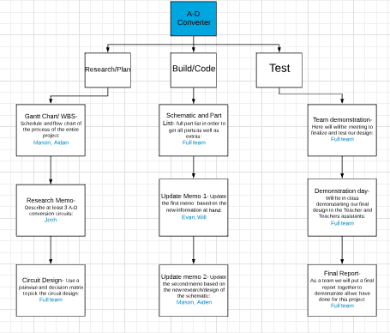

This WBS chart shows what we have to do to plan, build, and test our project. We have divided up the work between certain people in the group.

**Figure 2.**

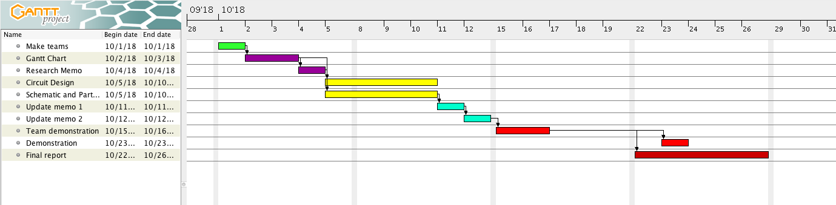

Make teams, Oct 2: On this day we decided our teams and started working on the Gantt chart and the WBS chart.

Milestone: We got to work as a team for our first time. We have a good group.

Gantt Chart; WBS, Oct 3: We will prepare a WBS chart to show how we conduct ourselves through the second project. We delegated roles for everyone to do certain tasks during this project.

Research Memo, Oct 4: The task is to research three different types of circuits for analog to digital conversion.

Circuit Design : We use a pairwise matrix and decision matrix to decide what which circuit we research will best fill our requirements.

Milestone: we will pick a final circuit and be able to start our schematic.

Schematic and Parts List: In this we will make a memo detailing which parts and additional parts we will receive after making a detailed schematic.

Update Memo 1, Oct 11: We will update Memo 1 based on new information and research.

Update Memo 2, Oct 18: We will update Memo 2 based on new information and research.

Team Demo, Oct 21: As a team we will meet and finalize our project. We will go through the requirements one last time to make sure our project fulfils every requirement we have set.

Demo, Oct 23: We will demonstrate our circuit to the professor and the Graduate students assisting the professor.

Final Report, Oct 28: We will finish the final report for the project, marking the end of project two.

Milestone: We will be finished with project two.

Both the Gantt Chart and WBS deliverables ensure that our team will remain on track for each assignment and accomplish our goal successfully. These documents will be beneficial to our team’s progress and will ensure that our team is on the same page as to who will be accountable for each deliverable and when deliverables will be due.